Runmotorsim.m
This script runs a simulation of a motor and plots the results alongside real data from motors
required file: motor_control.slx
Define motor parameters 1
Define control system gain 2
Run a Simulation 3
A Plot of the results 3

Define motor parameters
%k and sigma chosen such that simulation matches motors as much as possible
%
k=1.9; % DC gain [rad/Vs]
sigma=18; % time constant reciprocal [1/s]
%
%The image below depicts the results from simulating setting the motor
%voltage to 3.76V using the above parameters, compared with the actual real
%world data of doing the same. The big idea is that the parameters above
%allow the simulation to be as close to the real world system as possible,
%give or take some noise.
%
imshow('comparison.png')
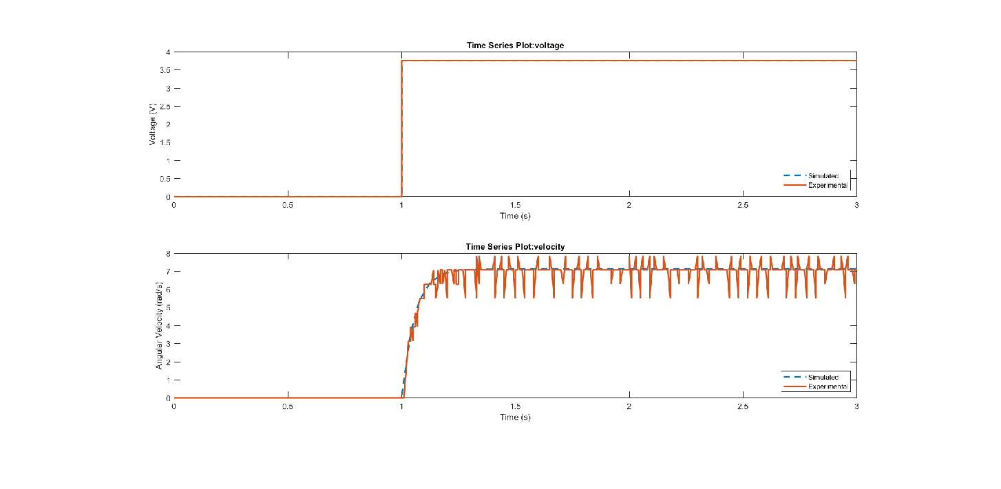

Define control system gain
%Gain Kp chosen such that simulated steady state velocity is within 20% of
%desired, without allowing system to be affected by noise too much
%
Kp = 10;
%
%The image below depicts the control simulation being set to 1 rad/s, with
%a gain of 10. The big idea is that the steady state velocity is able to
%get within 20% of the set value of 1 rad/s.
%
imshow('Kpsimulation.png')
%
%load 3 second control data from file (run motorControlAdvanced.ino and
%copy serial data to controlData.mat)
%
load('controlData.mat');
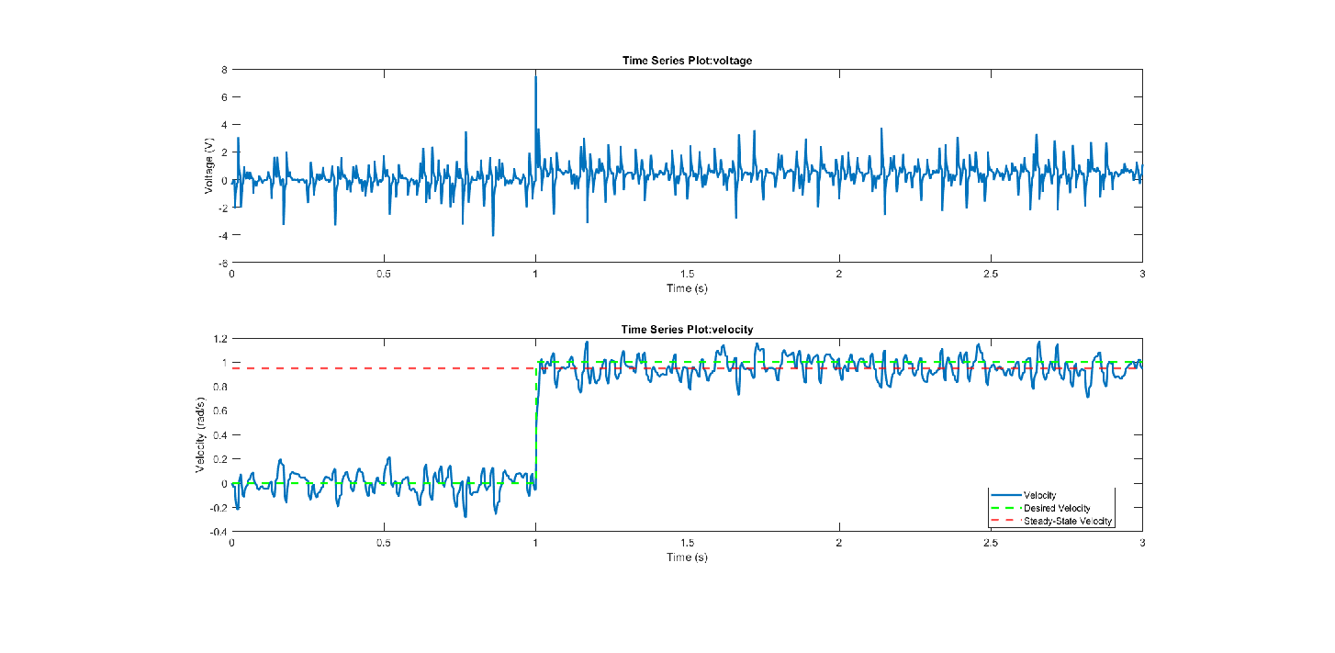

Run a Simulation
open_system('motor_control')
%
% run the simulation
%
out=sim('motor_control');
%
% The below image shows the control simulation mentioned earlier that is
% going to be run once again.
%

A Plot of the results
%The plot below shows the same control simulation as before being
%run with gain Kp set to 10. However, the set velocity is -6.28 (-2PI)
%rad/s, and data taken from the real world motor with the same setup is
%shown on top of it. The big idea is that the real world motor is able to
%reasonable achieve our set value in a similar fashion as our simulation,
%albeit with some noise in the mix.
%
figure
subplot(2,1,1)
plot(out.Voltage,'LineWidth',2)
hold on
plot(data3(:,1),data3(:,2),'y--','linewidth',2)
hold off
xlabel('Time (s)')
ylabel('Voltage (V)')
legend('Simulated Voltage', 'Actual Voltage')
subplot(2,1,2)
plot(out.Velocity,'linewidth',2)
hold on
plot(out.DesiredVelocity,'g--','linewidth',2)
% Compute steady-state velocity (final value of the sim)
v_ss = out.Velocity.Data(end);
% Add a horizontal line for steady-state velocity
yline(v_ss,'r--','LineWidth',2)
plot(data3(:,1),data3(:,3),'y--','linewidth',2)
hold off
xlabel('Time (s)')
ylabel('Velocity (rad/s)')
legend('Simulated Velocity','Desired Velocity','Simulated Steady-State Velocity', 'Actual Velocity','Location','best')
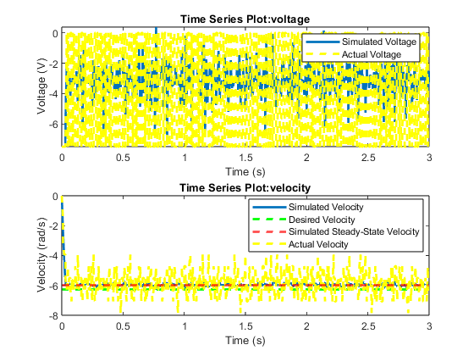
Published with MATLAB® R2024b

